A Passive Radar Approach to Satellite Proximity Event Detection

Dr. Lynnane George, PhD¹ and Joshua Pappas²
University of Colorado Colorado Springs, Colorado Springs, Colorado 80918

Nomenclature

Signals and Waveforms
$$r\left[n\right]= complex baseband reference signal (known copy of transmitted waveform)$$
$$s\left[n\right]=complex baseband surveillance signal$$
$$s_{DP}\left[n\right]=direct path interference component in surveillance channel$$
$$s_{T}\left[n\right]=target-reflected signal component$$
$s_{res}\left[n\right]=$residual surveillance signal after direct-path cancellation
$$w\left[n\right]=additive complex Gaussian noise$$
$$α=complex amplitude scaling factor accounting for propagation loss and target reflectivity$$

Time, Delay, and Doppler
$$n=discrete time sample index$$
$$f_{s}=sampling frequency (Hz)$$
$$τ=signal propagation delay (samples or seconds, as indicated)$$
$$f_{d}=Doppler frequency shift due to relative radial motion (Hz)$$
$$c=speed of light (m/s)$$

Cross-Ambiguity and Processing
$$χ\left(τ,fd​\right)= cross ambiguity function (CAF)$$
$$χk​\left(τ,fd​\right)=CAF for the k^{th} snapshot$$
$$χcoh​\left(τ,fd​\right)=coherently integrated CAF$$
$$M = number of snapshots used for coherent integration$$

Adaptive Filtering
$$w= complex NLMS filter weight vector$$
$NMLS=normalized least mean squares adaptive filter$

Detection and Statistics
$$CFAR=constant false alarm rate detector$$
$$CA CFAR=Cell Averaging CFAR$$
$$P_{fa}=probability of false alarm$$
$$SNR=signal to noise ratio$$

Simulation Parameters
$$BPSK=Binary Phase Shift Keying$$
$$SAR=Synthetic Aperature Radar$$
$$Inverse Synthetic Aperature Radar$$

Introduction
T
HE Earth orbital environment has become increasingly congested, contested, and competitive, with a growing number of active spacecraft operating in close proximity to one another. Concurrently, concern has grown regarding both unintentional close approaches—such as conjunctions and formation drift—and deliberate proximity operations conducted by non-cooperative or adversarial spacecraft. Together, these factors create a critical need for onboard spacecraft proximity detection capabilities that can identify nearby objects across a diverse range of operational scenarios. This need was made clear when the United States Space Force (USSF) published a list of needs in their Apollo Accelerator Problem Statements. Of these is:
“27. Detect Proximity Events
Automatically predict proximity events between space objects, leveraging tools such as COMBO+ (Computation of Miss Between Orbits). The capability must calculate start/stop times, time and point of closest approach, probability of collision, and relative kinematics. Outputs may also intersect with EO/IR Weapon Engagement Zones (WEZ) data. Predicting proximity events in advance is essential for space domain awareness, anomaly detection, and the assessment of potential threats or intelligence-gathering activity.” [1]

Traditional approaches to proximity awareness rely heavily on ground-based sensors, cooperative onboard systems, or dedicated active sensing hardware such as radar or lidar. While effective for cooperative spacecraft, these approaches can be limited by coverage gaps, operational constraints, and power availability. Furthermore, such systems offer limited effectiveness against spacecraft that deliberately maneuver to avoid detection or identification, motivating the need for alternative sensing approaches.
Passive radar techniques offer a compelling approach by exploiting existing radio-frequency emissions as illuminators of opportunity. Rather than transmitting a dedicated radar waveform, a passive radar system correlates a reference copy of an existing signal with reflections observed in a separate surveillance channel to detect and localize targets. Passive radar has been widely studied in terrestrial applications using commercial broadcast and communication signals; however, its application to space-based proximity sensing remains comparatively underexplored, particularly in the context of spacecraft using their own communication signals for local awareness.
This paper investigates a passive “tripwire” radar concept for spacecraft proximity detection that leverages a spacecraft’s normal communication waveform without modifying the transmitter or degrading its primary mission. In this semi-passive configuration, a reference copy of the transmitted signal is assumed to be available onboard, while a single surveillance receiver observes the surrounding environment. Reflections from nearby objects are embedded within strong direct-path interference and noise, requiring robust signal processing to extract weak target echoes.
To address this challenge, a simulation-based signal processing framework is developed that incorporates adaptive direct-path suppression, baseline cross-ambiguity fingerprinting, Doppler derotation, and coherent integration across multiple snapshots. Detection is performed in the delay–Doppler domain using constant false alarm rate (CFAR) thresholding. Rather than providing detailed target characterization, the system is intended to function as an initial detection layer, alerting the spacecraft to the presence of nearby motion and enabling subsequent classification or response using additional sensing modes if desired.
The primary contribution of this work is the demonstration, through simulation, that coherent processing of unmodified communication signals can enable reliable detection of a moving, non-cooperative target below the noise floor while maintaining transmitter mission compliance. The results support the feasibility of a low-impact proximity awareness capability that can operate continuously in the background and be extended in future work to interferometric, synthetic aperture, or multi-satellite cooperative sensing architectures.

Background and Related Work
Passive radar is a sensing paradigm in which targets are detected and localized by exploiting existing radio-frequency emissions, rather than by transmitting a dedicated radar waveform. In a passive radar system, a reference channel captures a copy of the illuminating signal, while a separate surveillance channel observes reflections from targets embedded within noise and interference. By correlating these two signals, delay–Doppler information can be extracted, enabling target detection and motion estimation without additional emissions from the sensing platform.
Foundational treatments of passive radar are provided by Griffiths and Baker, who describe the fundamental signal models, processing architectures, and performance considerations associated with illuminators of opportunity such as broadcast, communication, and navigation signals [2]. In terrestrial applications, passive radars use a wide variety of commercial emitters. These include FM radio, digital television, and cellular communications. These systems rely on strong, continuous transmissions and exploit coherent processing over time to overcome the often unfavorable signal-to-interference ratios associated with bistatic geometries.
More recently, the theory and performance limits of passive and multistatic radar systems have been formalized within a unified detection-theoretic framework. Zaimbashi and Nayebi present a comprehensive treatment of target detection in multistatic passive radar systems, addressing the statistical structure of the detection problem, the role of cross-ambiguity processing, and the impact of unknown or partially known signal parameters [3].
While passive radar is widely used worldwide in airborne and terrestrial environments, very little work has been done utilizing passive proximity awareness using onboard emissions. Existing space-domain sensing approaches typically emphasize cooperative systems, ground-based tracking, or dedicated active sensors, each of which introduces operational dependencies or resource constraints. The use of a spacecraft’s own communication signals as an illuminator of opportunity for local sensing introduces a distinct semi-passive configuration, in which the transmitter is non-compliant with radar operation but fully known to the receiver.
The concept explored in this paper aligns with prior passive radar research in its use of cross-ambiguity processing and coherent integration, while extending these ideas to a spacecraft-centric proximity sensing scenario. Rather than attempting detailed target imaging or classification, the proposed approach emphasizes initial event detection—functioning as a low-impact “tripwire” that can alert a spacecraft to nearby motion without modifying its communication waveform or degrading its primary mission. This focus distinguishes the present work from traditional passive radar applications and motivates the development of a simplified, simulation-based framework tailored to spacecraft neighborhood awareness.

System Concept and Signal Model

Semi-Passive System Concept
The system considered in this work is a semi-passive spacecraft proximity sensing architecture that leverages a spacecraft’s existing communication transmissions as an illuminator of opportunity. In contrast to active radar systems, no dedicated sensing waveform is transmitted, and the primary communication function of the spacecraft remains unmodified and undegraded during detection. The system is therefore classified as non-cooperative from a radar perspective, while still assuming full knowledge of the transmitted waveform at the receiver.
The conceptual architecture consists of two signal paths: a reference channel and a surveillance channel. The reference channel contains a clean copy of the transmitted communication signal, obtained onboard prior to radiation. The surveillance channel is formed by a single receiving antenna that observes the surrounding environment and contains a combination of direct-path leakage from the transmitter, additive noise, and reflections from nearby objects when present. Only a single surveillance antenna is assumed in this study, precluding spatial beamforming or angle-of-arrival estimation and emphasizing delay–Doppler processing as the primary sensing mechanism.
The intended role of the system is that of an initial proximity “tripwire,” providing event detection rather than detailed target characterization. Upon detection of nearby motion, more resource-intensive sensing or operational responses may be invoked. This layered approach motivates the use of a continuously operating, low-impact passive sensing capability.

Signal Model
The transmitted waveform is modeled as a baseband binary phase-shift keying (BPSK) signal sampled at rate $f_{s}$. The reference signal $r[n]$ is assumed to be perfectly known and synchronized at the receiver. In the simulation framework, the BPSK sequence may repeat periodically, reflecting the structure of practical communication waveforms.
The surveillance signal $s\left[n\right]$ is modeled as the superposition of three components:
$$\begin{aligned}s\left[n\right]=s_{DP}\left[n\right]+s_{T}\left[n\right]+w\left[n\right] \#(1)\end{aligned}$$

where ​$s_{DP}[n]$ represents the direct-path interference from the transmitter to the receiver,
$s_{T}[n]$ is the reflected signal from a target when present, and $w[n]$ is additive complex Gaussian noise.
The target echo is modeled as a delayed and Doppler-shifted replica of the reference signal:
$$\begin{aligned}s_{T}\left[n\right]=αr\left[n-τ\right]e^{\frac{j2πf_{d}n}{f_{s}}} \#\left(2\right)\end{aligned}$$
​where 𝛼 is a complex amplitude scaling factor that accounts for propagation loss and target reflectivity, 𝜏 is the bistatic propagation delay in samples, and $f_{d}$ is the Doppler frequency associated with relative radial motion. Fractional delays are applied using interpolation to avoid circular wraparound artifacts. The Doppler frequency is held constant within each snapshot but may vary between snapshots to model target motion over time.
The direct-path component $s_{DP}[n]$ is assumed to be a strong, potentially delayed version of the reference signal. In practice, this component dominates the surveillance channel and must be suppressed prior to detection of weak target echoes.

Snapshot-Based Motion Modeling
To capture temporal coherence and motion effects, the received data are processed in discrete snapshots. Each snapshot corresponds to a fixed observation interval during which the target delay and Doppler are assumed constant. Between snapshots, the target range is updated according to a prescribed radial velocity, resulting in evolving delay and phase history across the coherent processing interval.
This snapshot-based formulation enables coherent integration across time while remaining consistent with a passive sensing scenario in which continuous waveform transmission is present. It also provides a natural framework for examining the effects of coherent integration length on detection performance.

Direct-Path Suppression and Baseline Characterization
Prior to delay–Doppler processing, direct-path interference may be attenuated using an adaptive normalized least mean squares (NLMS) canceller. The canceller uses the reference signal to estimate the direct-path component present in the surveillance channel and subtracts the estimated contribution, yielding a residual signal with reduced interference power.
In addition to adaptive cancellation, a baseline cross-ambiguity function (CAF) is computed using a surveillance signal containing no target reflections. This baseline serves as a static fingerprint of residual system artifacts and clutter and may be subtracted from subsequent CAFs to further suppress non-target contributions.

Delay-Doppler Processing Overview
Target detection is performed in the delay–Doppler domain using the cross-ambiguity function between the reference and surveillance signals. The CAF is computed via FFT-based cross-correlation over a specified delay window and Doppler frequency span. For multiple snapshots, the resulting CAFs may be Doppler-derotated to maintain phase coherence prior to coherent integration.
The output of this processing chain is a delay–Doppler map in which moving targets appear as localized peaks. These maps form the input to the detection stage described in the following section.

Signal Processing Pipeline
The objective of the signal processing pipeline is to extract weak target reflections embedded within strong direct-path interference and noise, using only a reference copy of the transmitted communication signal and a single surveillance channel. The processing chain operates on discrete snapshots and produces delay–Doppler representations suitable for coherent integration and adaptive detection.

Direct-Path Suppression
In passive radar systems, the direct-path signal between transmitter and receiver typically dominates the surveillance channel, often exceeding target echoes by several orders of magnitude. To mitigate this interference, an adaptive normalized least mean squares (NLMS) filter is employed to estimate and suppress the direct-path component using the reference signal as input.
The NLMS filter adaptively estimates a complex weight vector $w$ that minimizes the error between the surveillance signal and a filtered version of the reference signal. The residual signal after cancellation is given by
$$\begin{aligned}s_{res}\left[n\right]=s\left[n\right]-{\hat{s}}_{DP}\left[n\right]\#\left(3\right)\end{aligned}$$
Where ${\hat{s}}_{DP}[n]$ is the estimated direct-path contribution. The filter is trained using a surveillance segment containing no target reflections, and the resulting weights may be applied to subsequent snapshots. This adaptive cancellation stage is optional and may be disabled to assess system performance without interference suppression.

Baseline Cross-Ambiguity Characterization
In addition to adaptive cancellation, a baseline cross-ambiguity function (CAF) is computed using a surveillance signal containing no target reflections. This baseline CAF captures static system artifacts, residual interference, and processing biases that persist across snapshots.
The baseline CAF serves as a fingerprint of the sensing system and may be subtracted from subsequent CAFs to further suppress non-target contributions. This subtraction is performed in the complex domain to preserve phase information required for coherent integration.

Cross-Ambiguity Function Computation
Target detection is performed in the delay–Doppler domain using the cross-ambiguity function between the reference and surveillance signals. For a given snapshot, the CAF is defined as
$$\begin{aligned}χ\left(τ,f_{d}\right)=\sum_{n}{r\left[n\right]}s^{*}\left[n-τ\right]e^{-\frac{j2πf_{d}n}{f_{s}}}\#\left(4\right)\end{aligned}$$

where $τ$is the time of delay and $f_{d}$ is the Doppler frequency. In practice, the CAF is computed efficiently using FFT-based cross-correlation over a bounded delay window and a specified Doppler frequency span.
The resulting CAF provides a two-dimensional representation in which moving targets appear as localized peaks corresponding to their delay and Doppler. The CAF is computed for each snapshot independently prior to integration.

Doppler Derotation and Coherent Integration
To exploit temporal coherence, CAFs from multiple snapshots are coherently integrated. Because target Doppler induces a phase rotation across snapshots, a Doppler derotation factor is applied prior to summation to maintain phase alignment. For each Doppler bin, the CAF is multiplied by a complex phase correction derived from the estimated Doppler frequency and snapshot timing.
Following derotation, the CAFs are coherently summed across $M$snapshots:
$$\begin{aligned}χ_{coh}\left(τ,f_{d}\right)=\sum_{k=1}^{M}{χk\left(τ,f_{d}\right)} \#\left(5\right)\end{aligned}$$

Under the assumption of phase coherence, the target signal adds linearly while noise adds incoherently, resulting in an improvement in signal-to-noise ratio proportional to $M$, corresponding to a processing gain of approximately ${10log}_{10}{(M)}dB$.

Detection and Peak Selection
Detection is performed on the coherently integrated CAF using constant false alarm rate (CFAR) processing in the delay–Doppler domain. A cell-averaging CFAR (CA-CFAR) detector is applied independently along the delay dimension for each Doppler bin. The local noise level is estimated using training cells surrounding a cell under test, excluding guard cells to prevent target leakage.
A detection is declared when the CAF magnitude exceeds an adaptive threshold corresponding to a specified probability of false alarm. Following CFAR processing, detected peaks are ranked by magnitude, and the strongest detections are reported. Estimated target range is obtained from the detected delay, while Doppler estimates provide an indication of relative radial motion.

Processing Flow Summary
The complete processing chain consists of the following stages:
- Signal Formation
The spacecraft’s transmitted communication signal is split into two paths: a reference channel $r[n]$, containing a clean copy of the transmitted waveform, and a surveillance channel:
$$\begin{aligned}s\left[n\right]=s_{DP}\left[n\right]+s_{T}\left[n\right]+w\left[n\right] \end{aligned}(1)$$
which contains direct-path interference, potential target reflections, and noise.

- Baseline Characterization (No-Target Case)
Using the reference channel and a surveillance signal containing no target reflections, a baseline cross-ambiguity function (CAF) is computed. This baseline captures static system artifacts and residual interference and serves as a fingerprint for subsequent subtraction.

- Optional Adaptive Direct-Path Cancellation
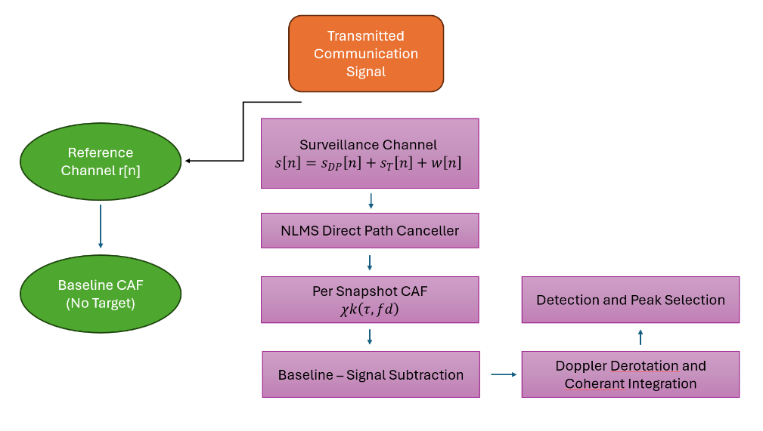
The surveillance channel may be processed by an NLMS-based adaptive canceller that uses the reference signal to estimate and suppress the direct-path component prior to ambiguity processing.

- CFAR-based detection and peak selection
For each snapshot, the reference signal is correlated with the (optionally cancelled) surveillance signal to produce a per-snapshot cross-ambiguity function
$$χk​\left(τ,fd​\right)$$
representing the delay–Doppler response for that snapshot.
Figure 1. Signal Processing Flow Chart

- Baseline Subtraction
The baseline CAF is subtracted from each per-snapshot CAF in the complex domain to further suppress static artifacts and non-target contributions while preserving phase coherence.

- Doppler Derotation and Coherent Integration
Per-snapshot CAFs may be Doppler-derotated to compensate for phase rotation due to target motion and then coherently integrated across multiple snapshots to enhance weak target responses.

- Detection and Peak Selection
The coherently integrated CAF is processed using CA-CFAR detection, followed by peak selection to identify candidate proximity events and estimate associated delay and Doppler values.

This modular pipeline enables systematic evaluation of each processing stage and supports direct comparison between single-snapshot and coherently integrated performance.

Simulation Framework
The proposed passive tripwire radar concept is evaluated using a simulation framework implemented in MATLAB. The simulation is designed to assess detection performance under controlled signal-to-noise conditions while preserving the assumptions of a non-compliant transmitter and a single-channel surveillance receiver.

Simulation Environment and Parameters
All simulations are conducted at complex baseband. The transmitted waveform is modeled as a binary phase-shift keying (BPSK) signal sampled at a rate of 10 MHz. Each simulation run processes a fixed number of samples per snapshot, with snapshot duration and count selected to examine the impact of coherent integration length on detection performance.
Key simulation parameters include the sampling frequency, maximum delay window, Doppler search span, probability of false alarm for CFAR detection, and the number of snapshots used for coherent integration. These parameters are configurable to enable sensitivity studies and stress testing of the processing pipeline.

Target and Motion Modeling
A single moving target is simulated using a bistatic propagation model. The target echo is represented as a delayed and Doppler-shifted replica of the transmitted waveform, with delay corresponding to the bistatic propagation time and Doppler corresponding to relative radial motion.
Target motion is modeled on a snapshot-by-snapshot basis. Within each snapshot, target delay and Doppler are assumed constant. Between snapshots, the target range is updated according to a prescribed radial velocity, resulting in evolving delay and phase history across the coherent processing interval. This formulation enables evaluation of coherent integration performance under realistic motion-induced phase evolution.
The target echo amplitude is scaled to represent weak reflections relative to the direct-path signal and noise floor. Additive complex Gaussian noise is applied to achieve a specified signal-to-noise ratio, which may be swept across simulation runs to assess detection robustness.

Signal Generation and Snapshot Structure
For each simulation attempt, a reference signal and two sets of surveillance signals are generated. The first surveillance signal contains only direct-path interference and noise and is used to compute a baseline cross-ambiguity fingerprint and, when enabled, to train the adaptive direct-path canceller. The second set consists of multiple surveillance snapshots that may include a target reflection in addition to direct-path interference and noise.
Each snapshot is processed independently through the cross-ambiguity function computation prior to any coherent integration. This structure enables direct comparison between single-snapshot and multi-snapshot performance and supports selective enabling or disabling of individual processing stages.

Processing Configuration and Evaluation
The simulation framework allows individual processing stages—such as adaptive direct-path cancellation, baseline subtraction, and Doppler derotation—to be enabled or disabled independently. This modularity supports controlled evaluation of each stage’s contribution to overall system performance.
Primary evaluation metrics include:
- Detectability of the target in the delay–Doppler domain
- Required number of snapshots for reliable detection
- Measured coherent integration gain compared to theoretical expectations
- Sensitivity of detection performance to signal-to-noise ratio
Detection success is defined by the presence of a CFAR detection within a specified range tolerance of the true target delay.

Demonstration Outputs
Simulation outputs include delay–Doppler heatmaps for individual snapshots and coherently integrated results, with true target locations annotated for reference. (Figure 1) Additional diagnostics, such as measured noise floor levels and processing gain estimates, are recorded to support quantitative performance assessment.
Together, these outputs provide both qualitative and quantitative insight into the effectiveness of the proposed passive tripwire radar concept.

Results
This section presents representative simulation results demonstrating the impact of coherent integration on target detectability in the proposed passive tripwire radar architecture. Emphasis is placed on qualitative and quantitative changes in the delay–Doppler response before and after integration.

Single Snapshot Delay-Doppler Response
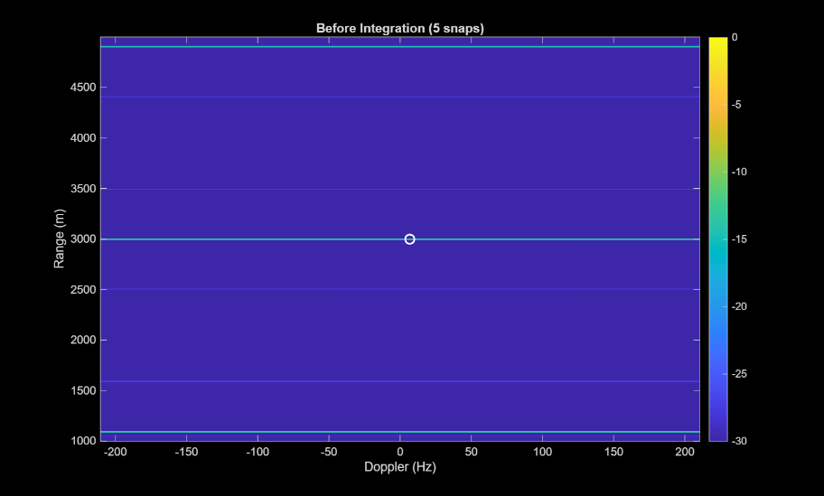
Figure 1(a) shows the magnitude of the cross-ambiguity function (CAF) prior to coherent integration, using five snapshots processed independently. The true target location is indicated by a marker at the known delay and Doppler corresponding to a target range of approximately 3 km and near-zero Doppler.
In this pre-integration case, the target response is largely indistinguishable from the surrounding noise floor. Although a weak localized increase in magnitude is present at the true delay, it does not rise significantly above background fluctuations and would not reliably exceed a CFAR detection threshold. This result illustrates the fundamental limitation of single-snapshot passive detection in low signal-to-noise environments, particularly when operating with a single surveillance channel and a non-cooperative transmitter.
Figure 2(a). Doppler Heat Map Before Coherent Integration. Doppler Frequency on X Axis, computed range to target on Y Axis. Color Represents signal amplitude compared to the noise floor in dB.

Coherently Integrated Delay Doppler Response
Figure 4(b) shows the coherently integrated CAF formed by summing the same five snapshots after Doppler derotation. At first glance, the integrated map appears visually noisier, exhibiting increased spatial variation across delay bins. However, this apparent increase in noise is accompanied by a substantially larger separation between the target peak and the surrounding noise floor.
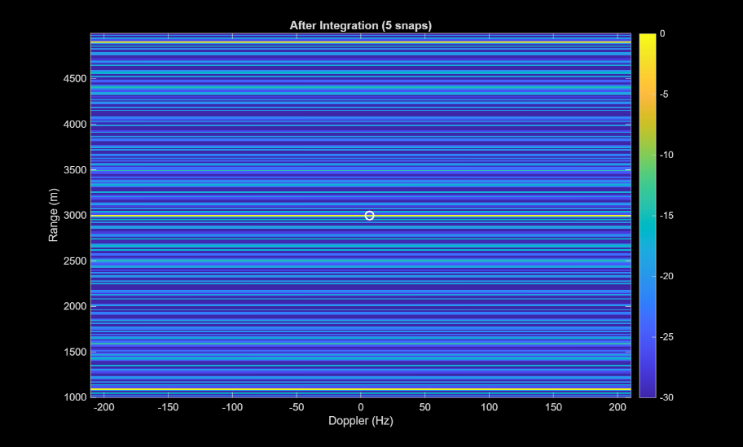
The coherent integration process causes signal components that are phase-aligned across snapshots to add constructively, while noise—being uncorrelated between snapshots—adds incoherently. As a result, the target response grows approximately linearly with the number of integrated snapshots, while the noise power increases only proportionally to the square root of that number. This produces a net improvement in signal-to-noise ratio consistent with the expected coherent processing gain.
In the integrated result, the target peak at the true delay becomes clearly distinguishable and exceeds adaptive detection thresholds, despite the presence of structured background variations. The increased contrast between the target and noise floor enables reliable detection even when the absolute noise level appears elevated.
Figure 2(b). Doppler Heat Map After Coherent Integration. Doppler Frequency on X Axis, computed range to target on Y Axis. Color Represents signal amplitude compared to the noise floor in dB. Note: Despite “Noisier” Image, difference between background dB and signal dB is greatly improved.

Interpretation and Detection Implications
The results demonstrate that visual smoothness of the delay–Doppler map is not a reliable indicator of detectability. While the post-integration CAF exhibits greater apparent noise texture, the statistical separation between target energy and background noise is significantly enhanced. This separation is the critical factor governing CFAR-based detection performance.
These results confirm that coherent integration is an effective mechanism for extracting weak moving targets from below the noise floor in a passive sensing context. Even with a limited number of snapshots, the processing pipeline enables event-level proximity detection without requiring transmitter modification or additional sensing hardware.

Summary of Observed Performance Trends
Across multiple simulation runs (not shown), increasing the number of coherently integrated snapshots consistently improved detection robustness, with measured processing gains aligning with theoretical expectations. The results validate the core premise of the proposed tripwire radar concept: that low-impact, semi-passive proximity detection is feasible using existing communication signals when appropriate signal processing techniques are applied.

Future Work
This work demonstrates the feasibility of a semi-passive, single-receiver “tripwire” for proximity event detection using an unmodified communication waveform. Several extensions are planned to expand capability from event detection toward localization, characterization, and imaging.
Where this can go next:
- Interferometric extensions
- SAR / ISAR modes
- Multi-band (“hyperspectral”) sensing
- Hardware-in-the-loop testing

Multi-Satellite Teaming and Ground-Fused Processing
A primary next step is extension to a multi-satellite teaming architecture. In this concept, each spacecraft forms its own reference and surveillance channels and produces time-tagged data products suitable for centralized processing. Rather than requiring onboard computationally intensive processing, each satellite can transmit either (i) raw complex baseband reference/surveillance snapshots, or (ii) compressed intermediate products such as cross-ambiguity surfaces and metadata, to a ground station.
A ground processor would then fuse measurements across platforms into a common picture. Multi-static diversity can enable improved spatial observability, including more accurate target localization and resolution of ambiguity inherent to a single-channel bistatic measurement. In particular, combining multiple delay–Doppler measurements from spatially separated receivers provides a path toward estimating a target’s absolute velocity vector rather than only radial approach/recede rate relative to a single receiver. Additionally, multi-platform fusion offers improved detection robustness through diversity gain and increased resilience to local interference, direct-path leakage, and shadowing.
Key technical tasks include (i) defining a timing and synchronization strategy sufficient for coherent or quasi-coherent fusion, (ii) establishing a common coordinate and ephemeris framework for measurement association, and (iii) developing a fusion method to convert multiple bistatic delay–Doppler observations into consistent state estimates with quantified uncertainty.

Mode Switching to Compliant Sensing for Characterization and Imaging
A second extension is the development of a compliant sensing mode in which the spacecraft temporarily transmits a deliberate detection waveform to enable higher-fidelity classification and imaging after a tripwire event. In this mode, the transmitter is no longer constrained to a communication-optimized waveform, allowing waveform design to prioritize sensing performance.
One promising direction is multi-band or multi-waveform operation to support “hyperspectral” radar-style characterization, in which reflections are collected across multiple frequencies or waveform families to improve discrimination between object types and surface properties. In addition, deliberate waveform transmission enables synthetic aperture processing, including synthetic aperture radar (SAR) or inverse SAR (ISAR) concepts, by collecting phase-coherent measurements over relative motion to increase effective aperture and improve spatial resolution.

Transitioning to this mode requires (i) waveform selection and spectral management consistent with mission constraints, (ii) signal processing adaptations to maintain coherence over longer integration times, and (iii) an imaging pipeline that leverages the tripwire detection result to gate processing resources and constrain the search region. This layered approach, continuous passive detection followed by on-demand active characterization, provides a practical path toward increasing capability while preserving nominal communications performance during routine operations.

Hardware-in-the-Loop Validation and Field Testing
A critical next step in the maturation of the proposed passive tripwire radar concept is validation using physical hardware. While the simulation results presented in this work demonstrate feasibility under controlled conditions, experimental testing is required to characterize real-world effects that are not fully captured in a software-only environment, including radio-frequency coupling, antenna patterns, hardware non-idealities, and environmental interference.
The first phase of experimental validation will be conducted using the University of Colorado Colorado Springs (UCCS) RF Anechoic Chamber. This facility enables controlled, repeatable testing of radio-frequency systems while isolating external interference and multipath effects. In this hardware-in-the-loop (HITL) configuration, representative communication waveforms will be transmitted using laboratory RF hardware, with a reference copy of the waveform captured prior to transmission. A separate surveillance receiver will observe direct-path leakage and controlled reflections introduced via calibrated scatterers or motion-controlled targets within the chamber.
This environment allows systematic evaluation of key algorithm components, including adaptive direct-path suppression performance, baseline cross-ambiguity characterization, coherent integration gain, and CFAR detection robustness under known signal-to-noise and signal-to-interference conditions. Timing, synchronization, and quantization effects introduced by real analog-to-digital converters and RF front ends can also be assessed. These experiments will provide a critical bridge between idealized simulation assumptions and practical implementation constraints.
Following chamber-based validation, the concept will be extended to outdoor field testing in a representative propagation environment. One proposed approach is the use of high-altitude balloon platforms to emulate key aspects of the space-domain sensing geometry, including long propagation paths, relative motion, and reduced ground clutter compared to terrestrial testing. In this configuration, a balloon-borne transmitter can emit a communication-style waveform, while ground-based receivers capture reference and surveillance channels for offline processing.
Field testing will enable evaluation of the algorithm’s robustness to atmospheric effects, platform motion uncertainty, timing drift, and unmodeled interference source. While a perfect simulation of the space environment, it is a fantastic first step to validate this method. Along with RF Anechoic experiments plus field experiments are a practical, incremental process validation strategy.
Together, RF anechoic chamber experiments and staged field testing represent a practical, incremental validation strategy. This approach supports progressive risk reduction, builds confidence in algorithm performance beyond simulation, and establishes a clear pathway toward future flight experiments or hosted payload demonstrations.

Conclusions
This paper presented a simulation-based investigation of a semi-passive proximity detection concept for spacecraft neighborhood awareness. By leveraging a spacecraft’s existing communication waveform as an illuminator of opportunity, the proposed approach enables continuous, low-impact sensing without degrading the primary mission or requiring modifications to the transmitted signal.
A modular signal processing pipeline was developed and evaluated, incorporating optional adaptive direct-path suppression, baseline cross-ambiguity characterization, delay–Doppler processing, Doppler derotation, coherent integration, and CFAR-based detection. Simulation results demonstrate that coherent integration across multiple snapshots provides substantial processing gain, enabling reliable detection of a moving target well below the noise floor using a single surveillance channel. While coherently integrated delay–Doppler maps may exhibit increased visual structure, the statistical separation between target energy and background noise is significantly enhanced, leading to robust detection performance.
The results validate the feasibility of a passive “tripwire” capability that can provide early warning of proximity events while maintaining transmitter compliance. Although the current implementation emphasizes event detection rather than precise localization or imaging, the architecture naturally supports future expansion. Extensions to multi-satellite teaming and deliberate sensing modes offer a path toward improved target state estimation, characterization, and imaging, while preserving the layered, low-impact philosophy of the system.
Overall, this work demonstrates that passive and semi-passive radar techniques can play a meaningful role in spacecraft proximity awareness, providing a scalable and mission-compatible foundation for future space domain sensing architectures.

Acknnowldgments
William Michael, M.S., Thank you for guiding this project through the code errors and occasional lack of direction
United States Space Force (USSF) Space Domain Awareness Tools, Applications, & Processing (SDA-TAP) Lab Cohort 9 for direct computing and processing support
MacKenzie Pappas, My 7-week old daughter, for sleeping through the night, enabling me to function and complete this project

References
- Griffiths, H., Baker, Christopher J., (Radar specialist), & Books24x7, I. (2017). An introduction to passive radar. Artech House. https://uccs.skillport.com/skillportfe/main.action?path=summary/BOOKS/132757
- Zaimbashi, A., & Nayebi, M. M. (2023).Multistatic passive radar target detection: A detection theory framework (1st ed.). The Institution of Engineering and Technology. https://doi.org/10.1049/SBRA561E

Associate Professor of Teaching, Mechanical and Aerospace Engineering, University of Colorado Colorado Springs, 1420 Austin Bluffs Pkwy, Colorado Springs, Colorado, 80918, Professional Member

