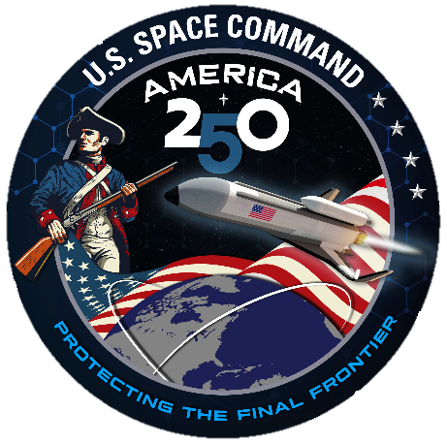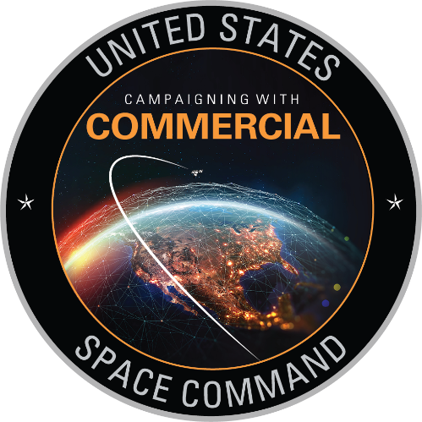
CALLING MESSAGE

U.S. Space Command’s APOLLO INSIGHT Wargame Series: Commercial Integration Tabletop Exercise
TTX #2 – Maneuver Warfare
24 June 2026, 0800-1730

- Purpose:
Provide registration information on the U.S. Space Command (USSPACECOM) Campaigning with Commercial (CwC) Mission Partners TOP SECRET Wargame Tabletop Exercise (TTX) #2 to be held at the Aerospace Facility in Colorado Springs, Colorado on 24 June 2026. The theme for TTX #2 is “Maneuver Warfare” and will again be conducted at the TOP SECRET//SI/TK//REL FVEY level with projected participation of every FVEY partner.

- TTX Background:
General Stephen Whiting, Commander USSPACECOM, designated 2026 as the Year of Integration within USSPACECOM. A key component of this effort is the continued collaboration with space‑focused Commercial Mission Partners (CMPs) and incorporating them into the Command’s campaign planning and tabletop exercise activities. To support this initiative, USSPACECOM began hosting quarterly wargame TTX events in 2026 that bring together commercial companies, USSPACECOM and Department of War SMEs, DOE national laboratory experts and many other professionals from across the space enterprise to address the complex challenges of partnering effectively in the space domain. Our shared goal is to ensure space superiority and uphold the principle that there is “Never a day without space”. This next TTX will build on the solid collaboration started during the March “WMD in Space” themed event.

- TTX Discussion:
During a December 2025 address to the Spacepower Conference in Orlando Florida, General Whiting challenged the long-standing myth that space was ever a peaceful domain. He asserts that space has been contested since its earliest days during the Cold War. The core of his address focused on the necessity of treating space as a warfighting domain, on par with land, air, sea, and cyber. Within that framework, he highlighted the significant asymmetric advantage offered by America’s rapidly expanding commercial space sector.

To fully harness this advantage, USSPACECOM has aligned its Commercial Integration Strategy around three key areas:
1. Identifying and advocating for commercial systems and innovations
2. Incorporating and operationalizing commercial capabilities
3. Informing and protecting commercial partners

4. Agenda: The TTX draft agenda is below. A more detailed agenda will be shared with all attendees following registration and acceptance to attend the TTX.
0700-0745: Check In & badging
0800-0830: Opening Remarks
0830-0945: Session 1: Topic TBD
0945-1000: Networking Break
1000-1130: Session 2: Topic TBD
1130-1230: Networking Lunch - Lobby area
1230-1400: Session 3: Topic TBD
1400-1430: Networking Break
1430-1600: Session 4: Topic TBD
1600-1630: Keynote Address by the Director of the China Aerospace Studies Institute
(CASI), Dr. Brendan Mulvaney
1630-1730: Open forum discussions attended by USSPACECOM leadership, USSF,
DOE national lab partners, the Commercial Integration Cell (CIC), the Joint Commercial Operations (JCO) cell, the Commercial Augmentation to Space Reserve (CASR), DOE national lab representatives and our commercial mission partners.

5. TTX Security Clearance Information: All attendees must possess a TS/SCI/SI/TK security clearance. USSPACECOM personnel will be able to access the Aerospace COS-2 facility using their blue badge.

Non-USSPACECOM personnel send clearance verification using the USSPACECOM Visit Authorization Request (VAR) Instructions below.

All Visit Authorization Requests (VARs) Must be received by NLT 22 May

VARs for Organizations utilizing DISS

USSPACECOM SMO Code: SSO-USSPACECOM-1

Plain Language Address (PLA): SSO USSPACECOM

SCI credentials must be submitted to USSPACECOM SSO by the cognizant authority (government agency holding each commercial company’s SCI certifications) and not directly by the security element within the commercial company. Direct company submissions of SCI certs will be rejected by the USSPACECOM J2 SSO team, may delay the processing and potentially affect attendance.

VARs for Organizations not utilizing DISS

Email a Memorandum for Record (MFR) using the following information:
- NIPR - send encrypted MFR to USSPACECOM.J2.SSO@us.af.mil
- JWICS – send MFR to DIA_USSPACECOM/J2SEC@coe.ic.gov
- Companies and government organizations holding the attendee’s SCI certifications MUST NOT send any security information to the event organizers – use the above email addresses. If you have questions, please reach out to the event POCs, however any security documentation not sent directly to the USSPACECOM J2 SSO contacts above may delay processing and potentially affect attendance.
- The MFR should follow these instructions:
  - Email Submissions: Clearances can be sent to official ".mil" email addresses for USSPACECOM/J2S, but they must be encrypted if sent via NIPR
  - Required Information: The visit certification must include the visitor's full name, social security number, rank, service/agency, nationality, clearance, and investigation/access details. It must also include the purpose of the visit, a USSPACECOM point of contact, and the certifying security officer's information.

U.S. Knowledgeable Person: POC: Mr. Mackenzie Mercer (719-552-3436) or Mr. David Mount (719-552-7374)

Event Location: Aerospace Facility COS-2, 7250 Getting Heights, C-Springs, CO 80916

Date of visit: 24 June 26

Visit Purpose: Attend USSPACECOM Apollo Insight Series Wargame TTX #2

Foreign Visit Requests (FVR): Foreign visitors must submit FVRs through their respective national embassy NLT 22 May 26. FVRs received after 22 May 26 risk being denied and will be reviewed on a case-by-case basis. Details for submission of an FVR through the Foreign Visits System follows:
- Purpose: Attend USSPACECOM hosted Apollo Insight Series Wargame TTX
- Date: 24 June 2026
- Organization: USSPACECOM J8
- Event Address: Aerospace COS-2, 7250 Getting Heights, Colorado Springs, CO 80916
- Visitor name(s): Please list all individuals planning to attend the event and include all substitutes/alternates/additions who may attend but are not yet confirmed. USSPACECOM will coordinate all visitors listed for one-time installation/facility access. Individuals added last-minute through an addendum or delayed FVR may experience a delay in processing.
- Facility POC: Angelica Martinez, 719-375-6058 Angelica.d.martinez@aero.org
- U.S. Knowledgeable Person: CDR Heather Thomas, USSPACECOM, J8, TTX Lead Planner, 719-552-7381, heather.thomas.8@usspace.com.mil

6. Facility Security:
- Cell phones and personal electronic devices: Not allowed in secure areas of the facility which are clearly marked, however, there are lobby boxes where you may leave your phone and devices (please turn them off).
- Electronic Medical Devices: Electronic medical devices (EMD) must be approved for use in secure facilities prior to being authorized for entry into any Aerospace collateral classified space, SCIF, or SAPF. All visitors with an EMD must provide an approved Department of the Air Force (DAF) Form 110, EMD Approval Card, or for non-DoD organizations, the waiver number. Failure to produce device approval documentation will result in delayed or denied access to the Aerospace facility, or removal and storage of the EMD for the duration of the event.
- Other Electronic Devices: Other than approved EMDs described above, all other electronic devices are strictly prohibited from entry into any Aerospace collateral classified space, SCIF, or SAPF; this includes DoD-issued fitness-tracking smart watches that may be approved in other DoD secure facilities. Visitors must leave prohibited electronic devices in their vehicle or store them in an electronics repository in the Aerospace facility. Electronics that are required to support meetings or conferences must be pre-coordinated and explicitly approved by the Aerospace Information Assurance team

7. Location: The TTX will take place at the Aerospace COS-2 Facility, 7250 Getting Heights, Colorado Springs, CO 80916. Visitor parking is available in front of the building. A map is provided below.
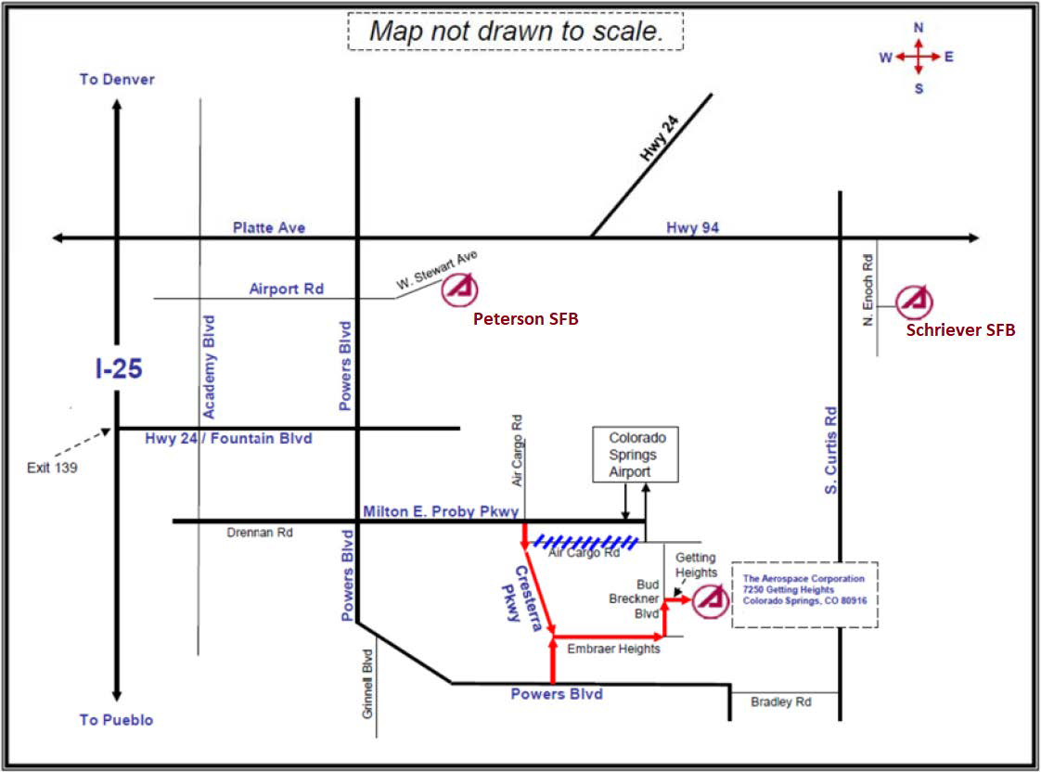

8. TTX Registration & Fee:
U.S. Space Command is unable to provide funding for travel or lodging to attend this TTX.

Registration will be open from 13 April through 1 June 2026. Use the following RegFox registration link to register and pay a conference registration fee of $35 plus a small processing fee which will cover all refreshments and lunch at the event: https://usspacecomprotocol.regfox.com/usspacecom-apollo-insight-ttx-2
Due to commitments to the catering company the registration fee is non-refundable. Receipts for this registration fee will be provided by the RegFox registration system. If needed the staff can provide a modified receipt upon request to capture additional information needed by your organization for reimbursement.

Registration and verified security clearances (VAR/FVR) must be completed NLT 22 May 2026. Unfortunately, due to the limited seating capacity at the Aerospace facility, registration does not guarantee approval to attend. TTX planners will contact registrants only if total numbers exceed seating capacity. We appreciate your understanding should we need to reduce the number of attendees. Please contact one of the event’s POCs with any questions regarding registration.

10. Attire: Attire for the event is uniform of the day (OCP) for military and business casual for civilians & contractors.

11. Event POCs:
CDR Heather Thomas, Commercial Integration Lead, USSPACECOM J811, Commercial & Technical Integration, heather.thomas.8@usspacecom.mil, Comm: 719-552-7381

Mr. David Mount, USSPACECOM J811, Commercial and Technology Integration, david.mount.2.ctr@usspacecom.mil, Comm: 719-552-7374

Mr. Marcel Arel, USSPACECOM J811, Commercial and Technology Integration, marcel.arel.1.ctr@usspacecom.mil, 719-552-7368

Ms. Debora Mosley, USSPACECOM J811, Commercial and Technology Integration, Debora.Mosley.2.ctr@usspacecom.mil, 719-552-7181

Mr. Adam Ressler, Wargame Planner, USSPACECOM J79, adam.ressler.2.ctr@usspacecom.mil, 719-552-7750

