AIR WAR COLLEGE
AIR UNIVERSITY

THE LETHALITY FRAMEWORK AND THE UNITED STATES SPACE FORCE

by

Alex Bohnert, GG-14, United States Air Force, Seminar 9

A Research Paper Submitted to the Faculty

In Partial Fulfillment of the Graduation Requirements

Primary Advisor: Dr. John M. Hinck

Secondary Advisors: Dr. Steven B. Davis

29 March 2026

Disclaimer
The views expressed in this academic research paper are those of the author and do not reflect the official policy or position of the US government, the Department of Defense, or Air University. In accordance with Air Force Instruction 51-303, it is not copyrighted, but is the property of the United States government.

Biography
Mr. Alex Bohnert is assigned to the Air War College, Air University, Maxwell AFB, AL. Mr. Bohnert started his civilian, all-source intelligence career in 2007 with the Space Analysis Squadron at the National Air and Space Intelligence Center (NASIC) at Wright-Patterson AFB, OH. Additionally, Mr. Bohnert served as the NASIC Liaison to AFSPC and NORAD-NORTHCOM at Peterson SFB, CO. Most recently, he served as the Current Intelligence Technical Advisor at the National Space Defense Center, Schriever SFB, CO. Prior to his civilian career, Mr. Bohnert commissioned into the Air Force as a Developmental Engineer at Officer Training School Maxwell AFB, AL in 2003. During his time as an Acquisitions Officer, he had assignments with the Air Force Research Laboratory at Kirtland AFB, NM and the Air Force Institute of Technology at Wright-Patterson AFB, OH.

Abstract

This paper analyses how the United States Space Force perceives lethality based on current doctrine and Senior Leader strategic messaging and argues for a codified emphasis on and definition of lethality in Space Force doctrine. The new lethality framework redefines lethality from capability-focused to a broader understanding of capability, innovation, and endurance through procedural lethality, adaptive lethality, and regenerative lethality. This paper recommends that the Space Force formally adopt the lethality framework to better align doctrine, operations, and Guardian training and development with space superiority, space control, and the Guardian Spirit. Doing so would strengthen the Service’s ability to achieve and maintain space superiority by focusing not just on capabilities but also on the human elements of lethality.

Key words: Lethality, Lethality Framework, Procedural Lethality, Adaptive Lethality, Regenerative Lethality, Space Force, Space Force Doctrine

Introduction
The character of war is evolving, driven by technological advancements and the emergence of space as the newest war-fighting domain. Additionally, the concept of lethality is changing with the character of war. Lethality can no longer be narrowly defined as the ability to kill or destroy; rather, it should encompass the capability, adaptability, and endurance to achieve mission success. Hinck et al. redefine lethality as the capability of a weapon, system, or force to kill the vitality of personnel or render materiel ineffective, leading to mission success. The new framework builds on procedural and adaptive lethality, while introducing the concept of regenerative lethality. Procedural lethality is tied to the materiel and training that enable combat, while adaptive lethality is tied to new strategies and the use of technology and materiel in novel ways. Regenerative lethality encompasses the human element and the ability to develop, endure, and succeed again.
This document applies the lethality framework directly to the United States Space Force. Current foundational publications, such as Space Force Doctrine Document 1 and the Space Warfighting Framework, lack an explicit definition of lethality. However, analysis of the current Space Force doctrine and the strategic messaging of Space Force senior leaders demonstrates that the Service implicitly embraces the procedural, adaptive, and regenerative elements of the proposed new lethality framework. The Space Force must transition from an implicit to an explicit doctrinal definition of lethality by formally adopting the framework of procedural, adaptive, and regenerative lethality, as this approach better captures mission success by linking space control, the Guardian Spirit, and Guardian resilience to space superiority and joint force success.

Thesis
The Space Force must transition from an implicit to an explicit doctrinal definition of lethality by formally adopting the framework of procedural, adaptive, and regenerative lethality, as this approach better captures mission success by linking space control, the Guardian Spirit, and Guardian resilience to space superiority and joint force success.

Background
This section provides a conceptual foundation for the lethality framework and United States Space Force doctrine. The Service published both the Space Force Doctrine Document 1 and the Space Warfighting Framework in April 2025. Additionally, this section analyzes Senior Leader strategic messaging throughout 2025 and applies it to the new lethality framework.
The Lethality Framework
Lethality is “typically understood as the capability of a weapon, system, or force to kill personnel or render materiel ineffective, with enhancement of one’s lethality aiming to create unfair fights at the tactical and operational level in support of strategic success.” Hinck et al. argue “that lethality includes not only the capacity to kill or destroy but also elements of learning and adaptation.” A new lethality framework can be constructed, utilizing the established concepts of procedural lethality, adaptive lethality, and vitality, by adding the novel concept of regenerative lethality. Lethality is not only how we fight, but also how we prepare to fight and re-fight.
Under the new lethality framework (see Figure 1), “lethality is redefined as the capability of a weapon, system, or force to kill the vitality of personnel or render materiel ineffective leading to mission success.” Procedural lethality refers to the process or sequence of steps required to achieve mission success. Adaptive lethality is the ability to adapt to the conditions presented or given to achieve mission success. Vitality is the power to develop, endure, and re-succeed. Vitality is the core enabler in generating and regenerating lethality. The new concept of regenerative lethality gives continuous life to the ability to attain personal and organizational vitality.
Regenerative lethality reflects the human element of lethality and consists of three sub-elements: mind, heart, and hand. The mind consists of cognitive and psychological sets of beliefs, the heart includes affective or emotional sets of values, and the hand element reflects behavior or physiological sets of skills.
Figure 1: The Lethality Framework

Space Force Doctrine Document 1
On 3 April 2025, Space Training and Readiness Command published Space Force Doctrine Document 1 (SFDD-1), The Space Force. According to the Chief of Space Operations, “Space Force Doctrine Document 1, The Space Force, codifies why we exist as a Service, who we are as Guardians, and how we employ spacepower to drive the success of the joint force.” SFDD-1 references the word “lethal” twice, in the context of space superiority and the security environment. While not explicitly defining Space Force lethality, it implicitly defines aspects of the lethality framework.
Procedural lethality is implicitly described in the Space Force’s mission statement: Secure our Nation's interests in, from, and to space. The Space Force has three core functions to achieve mission success: space control, global mission operations, and space access (see Figure 2). The core functions are enduring operational roles that to organize, train, and equip Guardians.
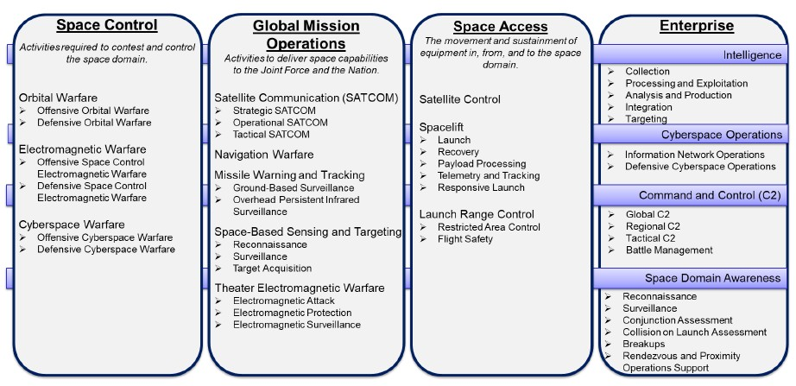
Figure 2: Space Force Core Functions
Adaptive lethality is SFDD-1 is implicitly referenced in the Guardian Spirit and through Mission command. A principle of the Guardian Spirit is to be a bold and collaborative problem solver; in other words, experiment, fail, learn, adapt, and innovate. Mission command empowers Guardians to exercise judgment in conducting their assigned tasks by emphasizing mutual trust, disciplined initiative, and innovation. It requires continuous cognitive effort to understand, adapt, and effectively direct mission success under evolving conditions and environments.
Regenerative lethality is implicitly defined in the Guardian Spirit, the Space Force Values, and the Space Force Structure. The Guardian Spirit embodies the Space Force's belief system and characteristics: a principled public servant, a space-minded warfighter, and a bold, collaborative problem solver. The Space Force Values of character, commitment, and courage build trust and unity, thereby strengthening and sustaining the force. Additionally, the motto “Semper Supra,” Latin for “Always Above,” captures the esprit de corps of the force. This belief system and value sets are the Space Force’s critical enabler of vitality (see Figure 3). The deployment of forces underpins regenerative lethality. The Space Force structures its forces to stay agile, streamlined, and mission-oriented, ensuring effective capability development, sustainment, and employment, enabling mission command, and maintaining standardization and flexibility as necessary. Ultimately, these concepts form the mind, heart, and hand elements of regenerative lethality.
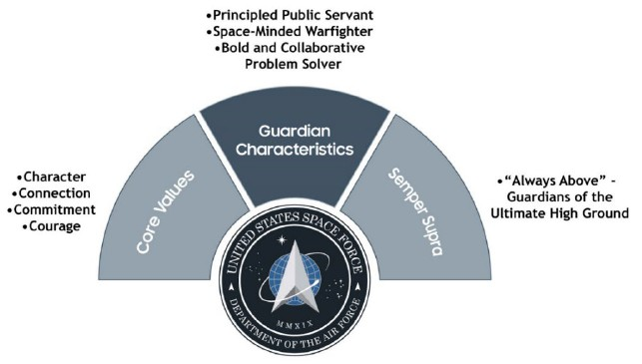
Figure 3: Values, Guardian Spirit, and Motto
Space Warfighting Framework
On 17 April 2025, the Space Force released its Space Warfighting framework, which outlines the service’s vision for achieving and maintaining space superiority while ensuring the sustainability of the space domain. According to the Chief of Space Operations, “It is the formative purpose of the Space Force to achieve space superiority, to ensure freedom of movement in space for our forces while denying the same to our adversaries, and we must be prepared to employ capabilities for offensive and defensive purposes to deter and, if necessary, defeat aggressors that threaten our vital national interests.” Additionally, the deputy chief of Space Operations for Strategy, Plans, Programs, and Requirements described the document as building on Space Force Doctrine to increase lethality and deter aggressors in space. “With Space Warfighting, we establish the counterspace framework necessary for Guardians to achieve space superiority, a precondition for Joint Force success.” The Space Warfighting framework mentions lethality three times, all in reference to space superiority and friendly or adversary capabilities.
In the context of the lethality framework, the Space Force considers vitality through the lens of space superiority. Space superiority is defined as “a degree of control that allows forces to operate at a time and place of their choosing without prohibitive interference from space or counterspace threats, while also denying the same to an adversary.” The goal of space superiority is to enhance the vitality of blue space capabilities and to diminish the vitality of adversary space capabilities (see Figure 4). Space Force vitality is enabled by space control, which includes offensive and defensive actions across the orbital, link, and terrestrial segments of the space architecture.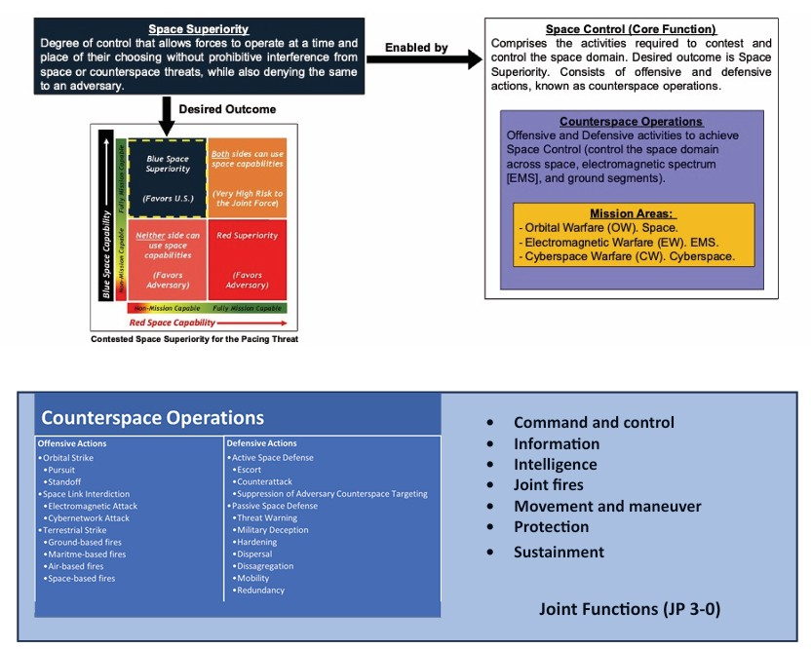
Figure 4: Concepts from Space Warfighting Framework
The offensive and defensive activities, also known as counterspace operations, in space force doctrine represent the procedural lethality of the lethality framework. To disrupt, degrade, deny, or destroy adversary space capabilities, the Space Force executes tasks to achieve space superiority. Offensive tasks include Orbital Strike, Space Link Interdiction, and Terrestrial Strike. Active space defense tasks include Escort, Counterattack, and Suppression of Adversary Counterspace Targeting. Passive space defense tasks include Threat Warning, Military Deception, Hardening, Dispersal, Disaggregation, Mobility, and Redundancy.
The Space Warfighting framework addresses adaptive lethality through Mission Command. In a contested, degraded, and operationally limited environment, the Space Force believes the most effective form of command and control is mission command. Regenerative lethality is addressed in the Space Warfighting framework through sustainment, which involves providing logistics and personnel services to keep operations running until mission success. The Space Force’s main challenge is to support increasing demand with limited resources in a contested environment. The Space Force is focused on four pillars of sustainment principles: the natural environment, the built environment, human capital, and mission systems.
Space Force Leaders' Comments on Lethality
The Chief Space Officer’s comments throughout 2025 clearly demonstrate all aspects of the lethality framework, combining procedural, adaptive, and regenerative lethality in the strategic messaging (see Table 1). Procedural lethality is consistently highlighted through references to combat-ready forces, space superiority, and space capabilities that support the Joint Force. Adaptive lethality is shown by evolving threats and a thinking adversary, urging Guardians to be critical thinkers, innovators, and risk-takers. The remarks also emphasize regenerative lethality repeatedly. References to the warfighter identity (Mind), commitment and courage (Heart), and skill development (Hand) reinforce that enduring space superiority relies not only on capabilities but also on the people.
Table 1: 2025 Chief Space Officer Comments and the Lethality Framework
Date | Event | Chief Space Officer Comments | Lethality Framework
11 Dec 2025 | Spacepower Conference | “In six short years, we’ve designed a force that’s ready to win… generated combat space forces ready to meet the demands of the Joint Force.” | Procedural
11 Dec 2025 | Spacepower Conference | “We need a new category of Guardians, multi-disciplinary critical thinkers ready to deliver combat wins at the pace of the threat.” | Adaptive
11 Dec 2025 | Spacepower Conference | “It's clear we've codified our identity as warfighters.” (Mind)  “Everything we do starts with you, the Guardians.” (Heart)  “We are developing the people, the products, and the processes necessary to ensure security and stability in the space domain.” (Hand) | Regenerative
23 Sep 2025 | Air, Space, & Cyber Conference | “The Joint Force’s ability to project power… depends directly on how well we deliver and sustain our space systems.” | Procedural
23 Sep 2025 | Air, Space, & Cyber Conference | “Continuous learning and rapid improvement are how we stay one step ahead of the adversary.” | Adaptive
23 Sep 2025 | Air, Space, & Cyber Conference | “For the first time ever, we’re providing 100% of our officers with initial training in space operations, cyber operations, intelligence, AND acquisition fundamentals before their first assignment.” (Mind)  “And most importantly, to our Guardians: You are the heart and soul of our mission.” (Heart)  “We must deliver with the quality that today’s space operations demands and be assured that these systems can survive the fight.” (Hand) | Regenerative
28 Aug 2025 | Officer Training School Graduation | “And your troops will demand you be measured, decisive, and experts in your craft.” | Procedural
28 Aug 2025 | Officer Training School Graduation | “And I implore you to take calculated risks, challenge the status quo with new ideas, and then take the initiative to implement them.” | Adaptive
28 Aug 2025 | Officer Training School Graduation | “You will be the ones who answer the call, you must be creative problem solvers, you must build expertise so you will have the courage and conviction to be bold.” (Mind)  “But great things require great daring … being courageous and bold enough to seize the initiative.” (Heart)  “And then be a part of the solution…we need problem solvers not just problem identifiers.” (Hand) | Regenerative
21 May 2025 | USGIF GEOINT Symposium | “The Space Force will operate GMTI as an application of its Global Mission Operations core function, enabling Combined Force lethality and closing long-range kill chains as part of our Title 10 responsibilities.” | Procedural
21 May 2025 | USGIF GEOINT Symposium | “When you break down the barriers between organizations, when you set aside tribalism and organizational orthodoxy, what you’re left with is singular focus on mission... and the creative solutions that focus inspires.” | Adaptive
21 May 2025 | USGIF GEOINT Symposium | “Space Superiority requires an extraordinary degree of trust, coordination, and shared commitment across organizations, commercial entities, and allied nations.” (Mind, Heart)  “We are placing a priority on “need to share” rather than “need to know.” That’s a fundamental shift in our thinking, and it will drive changes in the way we do business.” (Hand) | Regenerative
9 Apr 2025 | 40th Space Symposium | “Simply put, space superiority is now a prerequisite for battlefield success.” | Procedural
9 Apr 2025 | 40th Space Symposium | “I don’t have to tell this crowd that the space domain is evolving rapidly. New threats, new technology, and ever-increasing competition.” | Adaptive
9 Apr 2025 | 40th Space Symposium | “Space superiority requires an extraordinary degree of trust, coordination, and shared commitment among like-minded nations.” (Mind, Heart) | Regenerative
3 Mar 2025 | Warfare Symposium | “Space Control encapsulates the mission areas required to contest and control the space domain; employing kinetic and non-kinetic means to affect adversary capabilities through disruption, degradation, and even destruction, if necessary.” | Procedural
3 Mar 2025 | Warfare Symposium | “We must be ready to contest and control our domain. To overcome threats and outwit a thinking opponent. To build our systems to withstand a determined adversary.” | Adaptive
3 Mar 2025 | Warfare Symposium | “And the keystone in that arch, the thing that holds it all together … is the Guardians. It’s you.” (Mind)  “Whether you built the gun, pointed the gun, or pulled the trigger, you are a part of combat capability … that’s what it means to put on the uniform in a military organization, and we all need to take pride in our roles.” (Heart)  “As we continue to learn and grow, we will publish more doctrine and very likely revise what we’ve released … but SFDD-1 will always be our starting point.” (Hand) | Regenerative

The Chief Master Sergeant’s comments in 2025 also align with the lethality framework. Procedural lethality is consistently framed through the lens of fully trained, mission-ready crews with the skills and experience to execute the Joint Force's missions. Adaptive lethality is emphasized through Guardian innovation, rapid decision-making, and an evolving Force. The comments strongly reinforce regenerative lethality. The repeated focus on professional and warfighting culture, sacrifice and pride, and technical literacy directly maps to the lethality framework’s Mind, Heart, and Hand elements.
Table 2: Chief Master Sergeant of the Space Force Comments and the Lethality Framework
Date | Event | Chief Master Sergeant of the Space Force Comments | Lethality Framework
11 Dec 2025 | Spacepower Conference | “Operations often unfold through electronic interference, subtle orbital maneuvers, and other methods detectable only by highly trained specialists.” | Procedural
11 Dec 2025 | Spacepower Conference | "They must be able to make quick decisions with constantly evolving information.” | Adaptive
11 Dec 2025 | Spacepower Conference | “The modern warfighter requires technical literacy, cognitive agility and multi-domain awareness" (Mind)  “The future of the Space Force will be defined by the expertise, judgment, and culture cultivated by those serving today…” (Heart)  "We are developing programs that challenge Guardians to analyze, anticipate and respond in ways that were unimaginable for previous generations." (Hand) | Regenerative
27 May 2025 | Buckley Visit | “We look at Buckley SFB as a power projection platform that enables the other occurring missions.” | Procedural
27 May 2025 | Buckley Visit | “Our Airmen remain essential to our success…driving innovation across every function that supports space superiority.” | Adaptive
27 May 2025 | Buckley Visit | “You are all operators regardless of the badge you wear and the AFSC you have” (Mind)  “There is a sacrifice that comes along with being a member of the profession of arms. The pride we have in the work we do…” (Heart)  This visit was a catalyst for connection with the Guardians, Airmen, and civilians who control and contest the space domain. (Hand) | Regenerative
5 May 2025 | Warfighters in Action Event | "Our goal is to present fully trained, mission-ready crews using a model that aligns with Joint Force expectations" | Procedural
5 May 2025 | Warfighters in Action Event | “We are not just seeking interoperability; we are building it by design, ensuring seamless integration with our partners and allies.” | Adaptive
5 May 2025 | Warfighters in Action Event | “He described the “Guardian Experience” as a framework to enhance quality of life, cultivate warfighting skills, and plan for the future.” (Mind, Hand)  We are listening and acting to ensure their support and empowerment (Heart) | Regenerative
5 Mar 2025 | Warfare Symposium | “We are aligning our career structure to ensure Guardians have the skills and experience necessary to lead, even at junior ranks” | Procedural
5 Mar 2025 | Warfare Symposium | “What we did yesterday is not going to succeed today. We need innovative Guardians thinking outside the box, questioning assumptions, and evolving our service at the tactical level.” | Adaptive
5 Mar 2025 | Warfare Symposium | “He stated that the service must adopt a mindset of continuous change and improvement.” (Mind)  “We are building a foundation for generations to come. The challenges ahead will be tough, but they will be rewarding.” (Heart)  “He pointed to flashpoint exercises, space flag simulations, and technical development summits as key avenues for refining skills and improving operations.” (Hand) | Regenerative

Recommendations
The Space Force should doctrinally define lethality within the lethality framework of procedural, adaptive, and regenerative lethality. Currently, key Space Force documents, such as Space Force Doctrine Document 1 and Space Warfighting: A Framework for Planners, indirectly cover the elements of lethality. Additionally, strategic messaging by the Chief Space Officer and Chief Master Sergeant of the Space Force routinely highlights all aspects of the lethality framework.
The Space Force should clearly connect procedural lethality to offensive space control, as it reflects task proficiency or the series of steps needed to succeed in a mission. Space control operationalizes lethality through procedures that degrade, disrupt, deny, or destroy adversary capabilities across orbital, link, and terrestrial segments to support mission success. Furthermore, space control applies the current doctrinal use of task proficiency, including offensive actions such as orbital strike, space link interdiction, and terrestrial strike, to achieve and maintain space superiority. The intended outcomes of offensive space control operations are to reduce adversary vitality, specifically by reducing threats and increasing friendly force freedom from attack and freedom of action.
The Space Force should explicitly link adaptive lethality to the Guardian Spirit and Mission Command. Adaptive lethality is defined as the ability to transform to the conditions that are presented or given for mission success, which is envisioned in Space Force doctrine as being a bold and collaborative problem solver in the Guardian Spirit. It is characterized by a cultural philosophy of experimentation, failure, learning, adaptation, and innovation. The Space Force's doctrinal guiding principles of mission command and decentralized execution also align with adaptive lethality concepts. Mission command requires continuous cognitive effort to understand, adapt, and effectively direct the achievement of intent under evolving conditions and environments. Decentralized execution necessitates rapid decision-making and critical thinking to achieve the commander’s intent.
The Space Force should incorporate the mind, heart, and hand components of the regenerative lethality framework. The mind component is described in the space-minded warfighter characteristic of the Guardian Spirit in Space Force Doctrine Document 1. The space-minded warfighter is a Guardian dedicated to defending our Nation, safeguarding our interests, defeating our enemies, and skilled in using space capabilities against a thinking adversary. The heart element is also described in the Guardian Spirit as the principled public servant and with the Space Force’s core values. The Space Force values character, connection, commitment, and courage, along with selfless public service, which underpin trust in the Space Force. The hand element is implicitly referenced throughout Space Force doctrine, particularly in the development of Guardian foundational skills. Additionally, the Chief Space Operator has outlined an undeniable truth that encapsulates the Space Force’s purpose: “Guardians are uniquely and specifically trained, educated, and experienced in warfighting activities in, from, and to the space domain.”
The final recommendation for Space Force doctrine is to assess vitality, the power to develop, endure, and succeed again, not only through the lens of capabilities but also through individual resilience and sustainment. Current Space Force doctrine emphasizes vitality through space superiority and competitive endurance, both of which are primarily capabilities-focused. Space superiority is “the degree of control that enables forces to operate at a time and place of their choosing without prohibitive interference from space or counterspace threats, while denying the adversary the same.” Competitive endurance establishes the peacetime conditions required to sustain long-term competition and positions U.S. forces to prevail in conflict. The best way to strengthen the Space Force's vitality is to integrate the core values and Guardian Spirit with capability-focused concepts of space superiority and competitive endurance. Guardian resilience and the ability to fight, recover, and succeed again should be added to the definition of competitive endurance.

Conclusion
The analysis demonstrates that the Space Force currently operates with an implicit understanding of the new framework and definition of lethality. Current Space Force doctrine and Senior Leader strategic messaging align with the concepts of procedural, adaptive, and regenerative lethality, but they do not specifically define the concepts within the new lethality framework. Officially formalizing the lethality framework, which can be linked to current Space Force concepts, in doctrine will shape how the Service organizes, trains, and equips in the space domain. Specifically defining and reinforcing the concept of regenerative lethality will normalize the human dimension of warfighting and increase the Force’s ability to endure and to succeed again. The results of which would likely be a more resilient Force better postured to achieve and maintain space superiority.
Failure to define lethality risks ambiguity in doctrine, training, and strategic messaging. Without codifying the lethality framework in doctrine, specifically the concept of regenerative lethality, the Space Force risks setbacks in the human performance elements and may continue to treat lethality as just space superiority, which aligns more with the capability-focused definition of lethality. This could create future misalignment between how the Space Force fights and how Guardians are developed and trained.
This paper serves as an analytical starting point for how the Space Force initially views and messages the concepts of lethality in relation to the newly developed framework. Future work should refine how lethality is defined, measured, assessed, and sustained in the space domain. Moving forward, future studies could also analyze lethality from an operational space perspective based on current and historical conflicts.

Bibliography
“Chief Master Sgt. of the Space Force Visits Buckley SFB,” United States Space Force, June 2,
2025, https://www.spaceforce.mil/News/Article-Display/Article/4203392/chief-master-
sgt-of-the-space-force-visits-buckley-sfb/.
“CMSSF Discusses Enlisted Development, Operational Priorities,” United States Space Force,
May 7, 2025, https://www.spaceforce.mil/News/Article-Display/Article/4178020/cmssf-discusses-enlisted-development-operational-priorities/.
“CMSSF Highlights Evolving Warfighter Demands, Space Threats at Spacepower 2025,” United
States Space Force, December 12, 2025, https://www.spaceforce.mil/News/Article-
Display/Article/4358783/cmssf-highlights-evolving-warfighter-demands-space-threats-at-spacepower-2025/.
“Remarks by Chief of Space Operations Gen. Chance Saltzman at the USGIF GEOINT
Symposium,” United States Space Force, May 22, 2025, https://www.spaceforce.mil/News/Article-Display/Article/4195055/remarks-by-chief-of-space-operations-gen-chance-saltzman-at-the-usgif-geoint-sy/.
“Remarks by CSO Gen. Chance Saltzman at First Officer Training Course Graduation,” United
States Space Force, September 2, 2025, https://www.spaceforce.mil/News/Article-Display/Article/4291540/remarks-by-cso-gen-chance-saltzman-at-first-officer-training-course-graduation/.
“Remarks by CSO Gen. Chance Saltzman at the 2025 Air and Space Forces Association’s Air,
Space, and Cyber Conference,” United States Space Force, September 23, 2025, https://www.spaceforce.mil/News/Article-Display/Article/4313264/remarks-by-cso-gen-chance-saltzman-at-the-2025-air-and-space-forces-association/.
“Remarks by CSO Gen. Chance Saltzman at the 2025 Air and Space Forces Association’s
Warfare,” United States Space Force, March 3, 2025, https://www.spaceforce.mil/News/Article-Display/Article/4093775/remarks-by-cso-gen-chance-saltzman-at-the-2025-air-and-space-forces-association/.
“Remarks by CSO Gen. Chance Saltzman at the 2025 Space Force Association’s Spacepower
Conference,” United States Space Force, December 11, 2025, https://www.spaceforce.mil/News/Article-Display/Article/4357367/remarks-by-cso-gen-chance-saltzman-at-the-2025-space-force-associations-spacepo/.
“Remarks by CSO Gen. Chance Saltzman at the 40th Space Symposium,” United States Space
Force, April 11, 2025, https://www.spaceforce.mil/News/Article-
Display/Article/4153024/remarks-by-cso-gen-chance-saltzman-at-the-40th-space-symposium/.
“Top Space Force, Air Force Enlisted Leaders Discuss Readiness, Leadership,” United States
Space Force, March 14, 2025, https://www.spaceforce.mil/News/Article-
Display/Article/4108359/top-space-force-air-force-enlisted-leaders-discuss-readiness-
leadership/.
Hinck, John M., Robert S. Hinck, Jayson A. Altieri, and David R. Jarnot, “On Lethality: Toward
a More Complete Definition and Formation of The Lethality Framework,” The US Army War College Quarterly Parameters 55, no. 4, (Winter 2025-2026).
Space Force Doctrine Document (SFDD) 1, The Space Force, 3 April 2025.
United States Space Force, Space Warfighting a Framework for Planners, March 2025.

USSF Defines Path to Space Superiority in First Warfighting Framework,” United States Space
Force, April 17, 2025, https://www.spaceforce.mil/News/Article-Display/Article/4156245/ussf-defines-path-to-space-superiority-in-first-warfighting-framework/.

Hinck, John M., Robert S. Hinck, Jayson A. Altieri, and David R. Jarnot, “On Lethality: Toward a More Complete Definition and Formation of The Lethality Framework,” The US Army War College Quarterly Parameters 55, no. 4, (Winter 2025-2026): 119-120.
Ibid., 137.
Ibid., 130.
Ibid., 130.
Ibid., 131
Hinck, John M., Robert S. Hinck, Jayson A. Altieri, and David R. Jarnot, “On Lethality: Toward a More Complete Definition and Formation of The Lethality Framework,” The US Army War College Quarterly Parameters 55, no. 4, (Winter 2025-2026): 119.
Ibid., 119.
Ibid., 119.
Ibid., 120-121.
Ibid., 137.
Ibid., 137-138.
Hinck, John M., Robert S. Hinck, Jayson A. Altieri, and David R. Jarnot, “On Lethality: Toward a More Complete Definition and Formation of The Lethality Framework,” The US Army War College Quarterly Parameters 55, no. 4, (Winter 2025-2026): 138.
Ibid., 120.
Ibid., 138.
Ibid., 138.
Ibid., 138.
Ibid., 138.
Ibid., 137.
Space Force Doctrine Document (SFDD) 1, The Space Force, 3 April 2025, 3.
Ibid., 9.
Ibid., 21.
Ibid., 21.
Ibid., 21.
Space Force Doctrine Document (SFDD) 1, The Space Force, 3 April 2025, 14.
Ibid., 25-26.
Ibid., 26.
Ibid., 14.
Ibid., 13-14.
Ibid., 14.
Ibid., 13-14.
Space Force Doctrine Document (SFDD) 1, The Space Force, 3 April 2025, 15.
Ibid., 13.
USSF Defines Path to Space Superiority in First Warfighting Framework,” United States Space Force, April 17, 2025, https://www.spaceforce.mil/News/Article-Display/Article/4156245/ussf-defines-path-to-space-superiority-in-first-warfighting-framework/.
USSF Defines Path to Space Superiority in First Warfighting Framework,” United States Space Force, April 17, 2025, https://www.spaceforce.mil/News/Article-Display/Article/4156245/ussf-defines-path-to-space-superiority-in-first-warfighting-framework/.
Ibid.
Ibid.
United States Space Force, Space Warfighting a Framework for Planners, March 2025, 5.
Ibid., 3.
United States Space Force, Space Warfighting a Framework for Planners, March 2025, 3
Ibid., 8.
Ibid., 9.
United States Space Force, Space Warfighting a Framework for Planners, March 2025, 11.
Ibid., 5.
Ibid., 19.
Ibid., 19.
Ibid., 19.
“Remarks by CSO Gen. Chance Saltzman at the 2025 Space Force Association’s Spacepower Conference,” United States Space Force, December 11, 2025, https://www.spaceforce.mil/News/Article-Display/Article/4357367/remarks-by-cso-gen-chance-saltzman-at-the-2025-space-force-associations-spacepo/.
“Remarks by CSO Gen. Chance Saltzman at the 2025 Air and Space Forces Association’s Air, Space, and Cyber Conference,” United States Space Force, September 23, 2025, https://www.spaceforce.mil/News/Article-Display/Article/4313264/remarks-by-cso-gen-chance-saltzman-at-the-2025-air-and-space-forces-association/.
“Remarks by CSO Gen. Chance Saltzman at First Officer Training Course Graduation,” United States Space Force, September 2, 2025, https://www.spaceforce.mil/News/Article-Display/Article/4291540/remarks-by-cso-gen-chance-saltzman-at-first-officer-training-course-graduation/.
“Remarks by Chief of Space Operations Gen. Chance Saltzman at the USGIF GEOINT Symposium,” United States Space Force, May 22, 2025, https://www.spaceforce.mil/News/Article-Display/Article/4195055/remarks-by-chief-of-space-operations-gen-chance-saltzman-at-the-usgif-geoint-sy/.
“Remarks by CSO Gen. Chance Saltzman at the 40th Space Symposium,” United States Space Force, April 11, 2025, https://www.spaceforce.mil/News/Article-Display/Article/4153024/remarks-by-cso-gen-chance-saltzman-at-the-40th-space-symposium/.
“Remarks by CSO Gen. Chance Saltzman at the 2025 Air and Space Forces Association’s Warfare,” United States Space Force, March 3, 2025, https://www.spaceforce.mil/News/Article-Display/Article/4093775/remarks-by-cso-gen-chance-saltzman-at-the-2025-air-and-space-forces-association/.
“CMSSF Highlights Evolving Warfighter Demands, Space Threats at Spacepower 2025,” United States Space Force, December 12, 2025, https://www.spaceforce.mil/News/Article-Display/Article/4358783/cmssf-highlights-evolving-warfighter-demands-space-threats-at-spacepower-2025/.
“Chief Master Sgt. of the Space Force Visits Buckley SFB,” United States Space Force, June 2, 2025, https://www.spaceforce.mil/News/Article-Display/Article/4203392/chief-master-sgt-of-the-space-force-visits-buckley-sfb/.
“CMSSF Discusses Enlisted Development, Operational Priorities,” United States Space Force, May 7, 2025, https://www.spaceforce.mil/News/Article-Display/Article/4178020/cmssf-discusses-enlisted-development-operational-priorities/.
“Top Space Force, Air Force Enlisted Leaders Discuss Readiness, Leadership,” United States Space Force, March 14, 2025, https://www.spaceforce.mil/News/Article-Display/Article/4108359/top-space-force-air-force-enlisted-leaders-discuss-readiness-leadership/.
Space Force Doctrine Document (SFDD) 1, The Space Force, 3 April 2025, 23.
United States Space Force, Space Warfighting a Framework for Planners, March 2025, 9.
United States Space Force, Space Warfighting a Framework for Planners, March 2025, 9.
Space Force Doctrine Document (SFDD) 1, The Space Force, 3 April 2025, 14.
Space Force Doctrine Document (SFDD) 1, The Space Force, 3 April 2025, 14.
Space Force Doctrine Document (SFDD) 1, The Space Force, 3 April 2025, 26.
Space Force Doctrine Document (SFDD) 1, The Space Force, 3 April 2025, 25.
Space Force Doctrine Document (SFDD) 1, The Space Force, 3 April 2025, 14.
Space Force Doctrine Document (SFDD) 1, The Space Force, 3 April 2025, 14.
Space Force Doctrine Document (SFDD) 1, The Space Force, 3 April 2025, 3.
Space Force Doctrine Document (SFDD) 1, The Space Force, 3 April 2025, 21.
Space Force Doctrine Document (SFDD) 1, The Space Force, 3 April 2025, 12.

